Melbourne’s Annual Water Outlook 2025

December 2024

Acknowledgement
We respectfully acknowledge the Traditional Owners of the Greater Melbourne region as the original custodians of this land and water upon which we rely and operate. We recognise their continuing connection to land, waters and culture.
In the spirit of reconciliation and recognition of First Nations water knowledge and values, we remain committed to genuinely partnering with the Bunurong, Djaara, Gunaikurnai, Taungurung, Wadawurrung and Wurundjeri Woi Wurrung Traditional Owner groups and all First Nations people. These partnerships will ensure ongoing contribution of Traditional Owners to the future of water management while maintaining cultural and spiritual connections.

Summary

Current snapshot

2024 in review
- Melbourne’s population grew by around 140,000. This is more than the entire city of Ballarat.
- We saw water use slightly increase from 161 to 163 litres per person per day.
- Inflows into Melbourne’s four major storages were 507 billion litres or 5% above the 30-year average.

Current
- 88.4% storage level (6.6% down from the same time last year)
- Storage levels remain high.

The year ahead
- No water restrictions expected, but permanent water savings rules apply
- Warmer and slightly wetter climate outlook
- Our population will continue to grow, so we must continue investing in infrastructure to support growth
- Melburnians are encouraged to make every drop count.
Storages are high now, but they can drop quickly. With our growing population and increasingly variable climate, we need to continue planning for new water sources.

Where Melbourne’s water comes from
Melbourne’s drinking water comes from a system of rivers, reservoirs and desalinated water from the Victorian Desalination Plant. The plant has provided 455 billion litres of water (around one year of current supply) since 2017.
Inflows into Melbourne's storages are highly variable, but on average are not enough to supply our growing population. Annual orders of desalinated water, when needed, help keep our storages high, providing an essential buffer against dry conditions and severe droughts.
We continue planning to add new water sources to our system to meet our growing demands and encourage people to use water responsibly.

Enough water for the future
Water is a ﬁnite resource. With a growing population and changing climate, we must do what we can to protect our precious drinking water, now and into the future.
Together, the metropolitan water corporations — Greater Western Water, Melbourne Water, South East Water and Yarra Valley Water, along with regional water corporations — work hard to make sure safe and reliable water is available for all of Greater Melbourne and connected regional areas. That includes planning for the short, medium and long term to meet the challenges we face.

The challenges we face
- Growing population and water demand: Greater Melbourne’s population is projected to double by 2070, which means we’ll need to invest in more infrastructure to support growth.
- Climate variability: While Melbourne saw average rainfall this year, neighbouring system, Geelong saw well below-average rainfall. This reflects short-term weather changes, that require us to be adaptable.
- A changing climate: Over the long term, Victoria will become warmer and drier, with less water flowing into our dams.
- Our region is changing: We must balance environmental, economic and cultural water demands.
Investing in infrastructure to support growth
Melbourne’s population grew by around 140,000 people over the past year —- more than the entire city of Ballarat — and is projected to continue. To support current and future growth, in late 2023 the Victorian Government announced Victoria’s Housing Statement, its commitment to build new homes and connect homes to essential services more efficiently.
As both our population and water needs increase, sustained investment in water and sewerage infrastructure is critical to ensure that all new communities and developments have reliable access to the essential services they rely on.

What you can do
Although Melburnians have already committed to make every drop count, there’s more we all can do.
Find more ways to save our precious water.
- Shave a minute off your shower.
- Turn off the tap when you brush your teeth.
- Go easy with the hose and use a trigger nozzle.
If we each save a little, we all save a lot.

Where Greater Melbourne’s water comes from
Melbourne’s water corporations – Greater Western Water, South East Water and Yarra Valley Water, in partnership with Melbourne Water, our wholesale provider work together to deliver water across Greater Melbourne (Figure 1).
Delivering a high-quality and resilient water supply for a growing population is a priority.
Our precious drinking water is delivered from rivers, reservoirs and the Victorian Desalination Plant.
Our system of rivers and storage reservoirs across Melbourne and the surrounding region is largely fed by protected catchments in the Yarra Ranges and Upper Thomson River basin. On average, inflows into Melbourne’s storages are not enough to supply our growing population.
The Victorian Desalination Plant is a core part of our water supply system because it can supply up to 150 billion litres of water every year, or around one third of Melbourne’s current annual water demand. Annual orders of desalinated water, when needed, help keep our storages high, providing an essential buffer against dry conditions and severe droughts.
Without desalinated water, it’s very likely we would have experienced water restrictions in the years since the plant was built.
Over the past decade, the Melbourne water supply system has become increasingly connected with neighbouring systems, which is referred to as ‘the water grid’. A better-connected system helps improve water security for Melbourne and the surrounding region.
We continue planning to add new water sources to our system to meet our growing demands and encourage people to use water responsibly.
Use of desalinated water gives us the flexibility to adapt to current conditions and keeps storages high, so we’re prepared for growing water demands and climate variability.

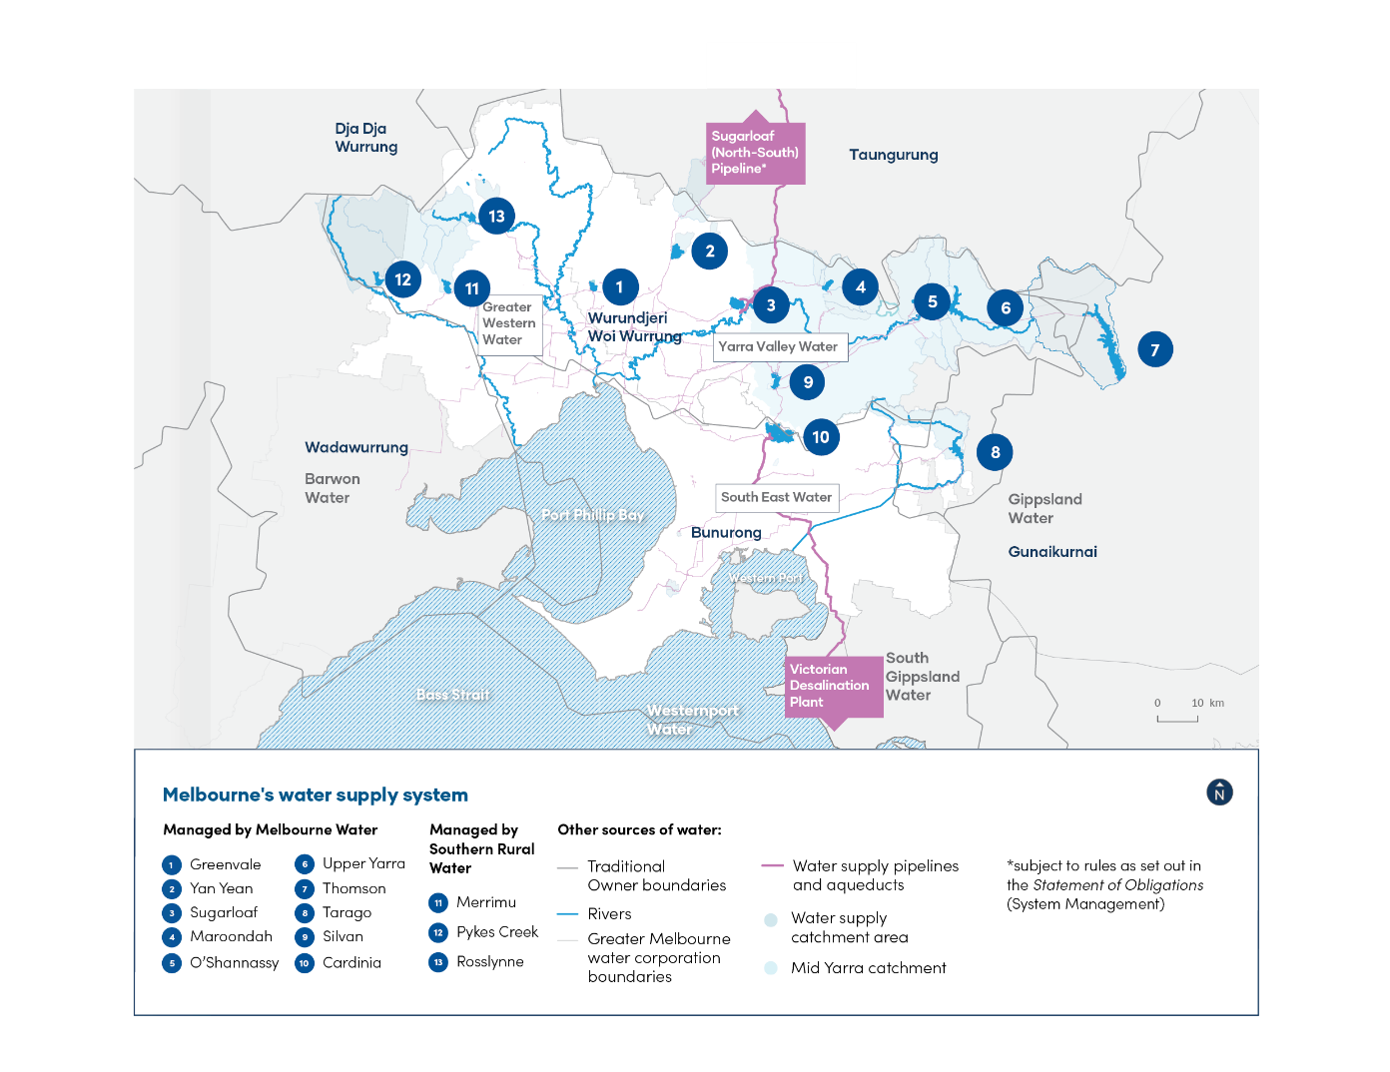
Figure 1: Where Melbourne’s water comes from
What water corporations are doing:
Harnessing digital technologies to help save precious drinking water
Water corporations continue to harness digital technologies to help save drinking water, reduce impacts to customers and operate more efficiently.
Digital meters allow customers to track their water use in near real-time, so they can take action to fix leaks and find ways to save water. By implementing one of Australia’s largest digital meter rollouts, South East Water has so far saved 1.32 billion litres of drinking water and its digital meter customers $5.6 million off their bills from leak detection at their property. This equates to 683 million litres and $2.9 million during 2023–24 alone. By avoiding costs of property damage caused by long-term undetected leaks, customers save even more.
The organisation is also increasingly saving drinking water that would otherwise be lost from its wider network through new advanced data analytics capabilities. This means network leaks are detected faster and more precisely through digital technologies before they become bursts, helping save 140 million litres in 2023–24.
Replacing analogue meters with digital meters is a key ‘water efficiency’ initiative within the Greater Melbourne Urban Water and System Strategy (GMUWSS).
Find out more about the GMUWSS on page 16.

2024 in review

Our water use
Melbourne’s population grew by around 140,000 and we saw water use slightly increase in 2024.
Residential water use was 163 litres per person per day (Figure 2), which accounted for 66% of Melbourne’s total water use in 2023–24 (Figure 3). This is slightly higher than residential use in 2022–23 of 161 litres per person per day.
This slight increase aligns with the Greater Melbourne Urban Water System Strategy water use projections (Figure 4).
Given the increasing impacts of our growing population and climate change, it’s more important than ever that we continue to use water responsibly.
That means we should each aim to achieve Melbourne’s target of 150 litres per person per day.
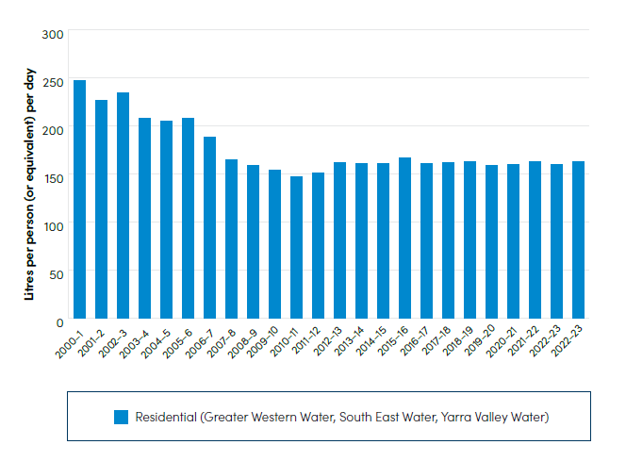
Figure 2: Water use in Melbourne
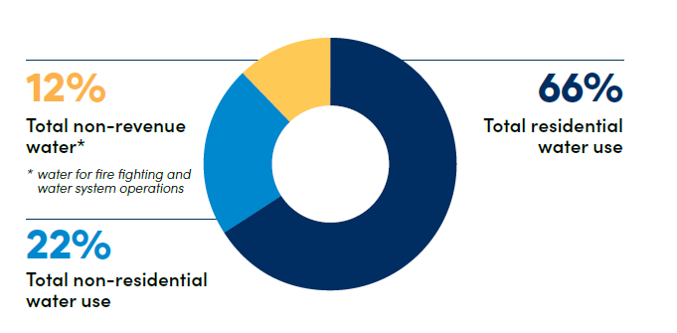Figure 3: Water use breakdown across Melbourne for total non-revenue, non-residential and residential water. *Non-revenue water is water that is lost, stolen or given away without generating revenue.
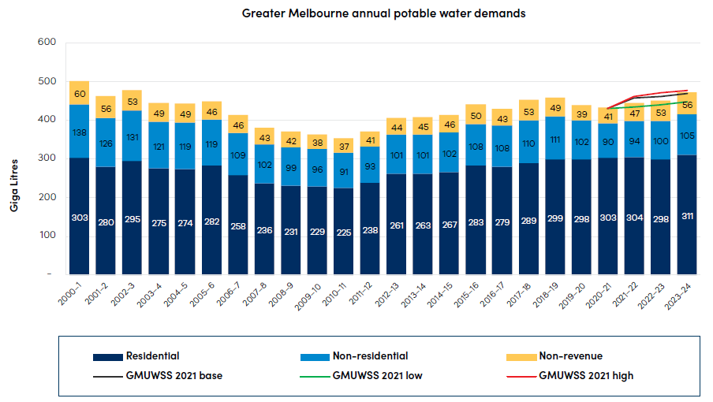Figure 4: Melbourne’s annual potable water demand against the Greater Melbourne Urban Water System Strategy projections.
Rainfall and storages
In 2023–24, Melbourne experienced slightly above average rainfall and inflows to storages, after three years of high rainfall and inflows. In 2023–24 inflows to Melbourne’s four major storages were 507 billion litres or 5% above the 30-year average.
The Melbourne retailers have an entitlement to 63% of the water in Melbourne’s storages. The remainder is allocated to other entitlement holders, such as regional water corporations, the Victorian Environmental Water Holder and irrigators. There’s also a volume not able to be accessed under normal conditions as it would increase risks to our infrastructure or the quality of water we supply.

How climate influences water storages
Victoria’s climate and streamflows are highly variable, but within this variability we’ve experienced a warming and drying trend over recent decades.
Victoria’s climate will continue to be variable with wet and dry years, against a background drying trend. With a warmer future and projections of declining water availability, we can expect more frequent and severe droughts in coming decades and increases in extreme rainfall events.
The Bureau of Meteorology (BoM) El Nino-Southern Oscillation (ENSO) outlook is currently neutral, but a ‘La Nina Watch’ remains. This projects slightly above median rainfall for Melbourne (Figure 5) and above 65-80% chance of exceeding median maximum temperature (Figure 6) across Melbourne over the coming three months.

Warmer temperatures tend to increase water use, particularly during summer, as more water is used to water gardens, parks and sports grounds.
Lower rainfall into storages over the long term and a growing population mean our reservoir levels can drop quickly.

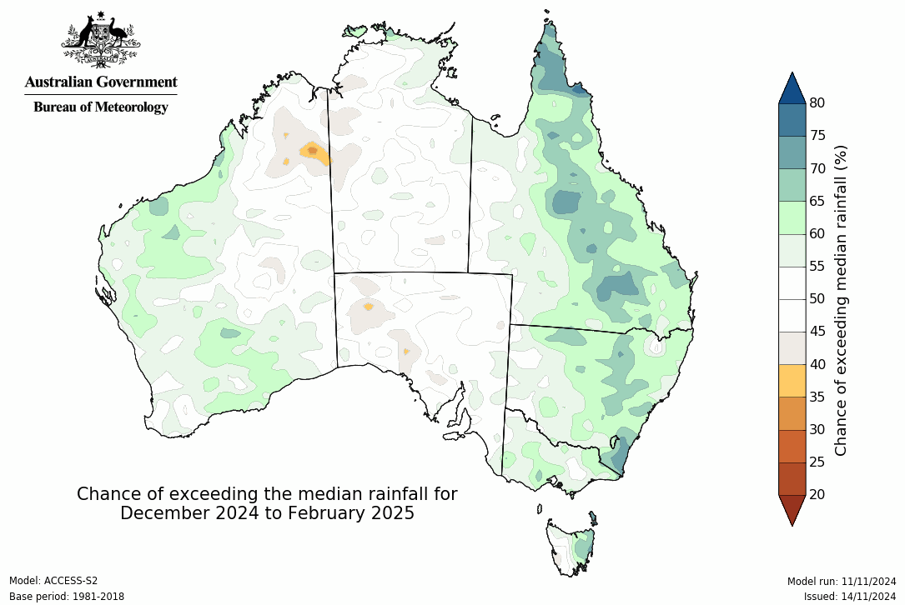
Figure 5: Seasonal rainfall outlook for December 2024 to February 2025.

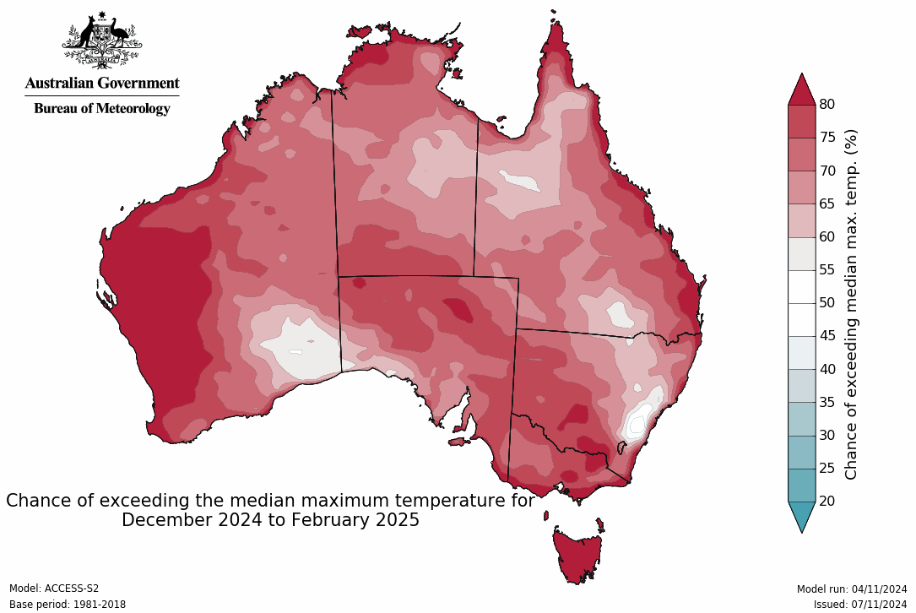
Figure 6: Seasonal temperature outlook for December 2024 to February 2025.
What water corporations are doing:
Pilot program helps customers save water, energy and money.
Yarra Valley Water is investing $5.25 million over 2023–28 to deliver a Water Audit and Appliance Efficiency pilot to help customers save water, energy and money. Over the five-year period, 15,000 homes are eligible for a free water audit and free showerhead replacement. We’ve already completed more than 800 audits and installed water efficient showerheads at more than 500 properties.

Qualified plumbers conduct comprehensive audits and eligible customers can replace up to four inefficient showerheads with water efficient alternatives. We estimate a 5-star WELS rated showerhead can save up to 20 kilolitres of water per household per annum, with savings of about $150 a year off water and energy bills.

This initiative supports the Victorian Government’s Target 150 campaign, which encourages Melburnians to reduce their average daily water usage from 163 litres to 150 litres a day.

The year ahead

Storage position
Melbourne’s storages remain high (88.4% as of 25 November 2024). This means we are in the ‘Be Responsible’ Water Outlook Zone (Figure 7).
Under most scenarios, storage levels over the next 12 months are expected to remain in the ‘Be Responsible’ Water Outlook zone (between 75% and 100%) (Figure 7).
Due to high storage levels, no desalinated water is being delivered in 2024–25. While the Melbourne system has experienced slightly above average rainfall and inflows, neighbouring systems in western Victoria has seen dry conditions and below average rainfall during 2024. This means we must be adaptable.
Even with high storage levels and regular orders of desalinated water, under persistent dry conditions, storages can fall very quickly. Once storages reach lower levels, water restrictions would almost certainly be required.
Despite recent wet periods, we know we’ll experience dry and extremely dry years. Annual orders of desalinated water, when needed, help keep our storages high, providing an essential buffer against dry conditions and severe droughts.
Current storage levels 88.4% as of 25 November 2024 (6.6% down from the same time last year).
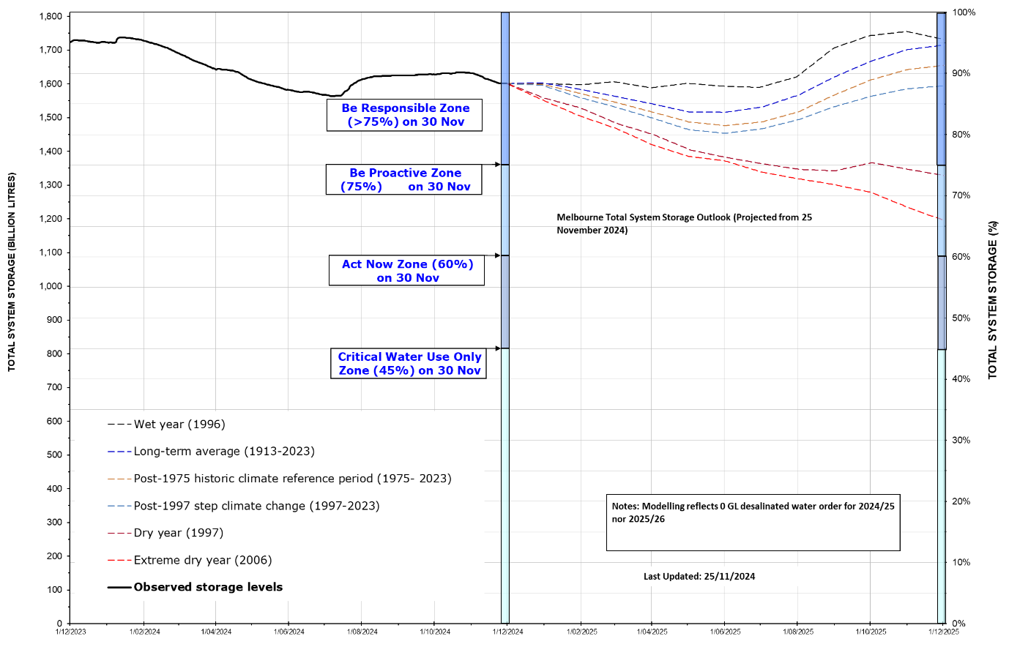
Figure 7: Melbourne total storage system 2024–25, projected as of 25 November 2024.
Figure 7: Melbourne total storage system 2024–25
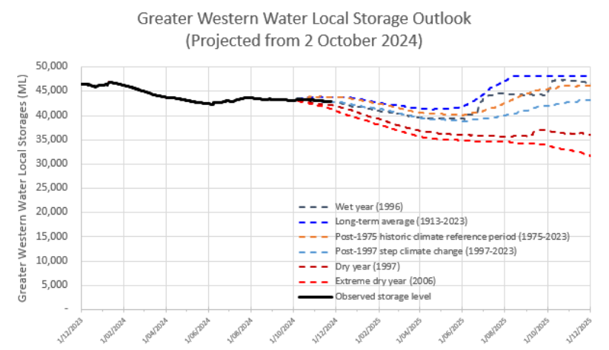
Figure 8: Greater Western Water storage outlook 2024–25
Some towns in the northwest of the Greater Western Water service region are supplied from multiple sources, including surface water, groundwater and they also rely on a regional water grid. Greater Western Water currently holds 36.6 billion litres in Merrimu and Rosslynne systems (Figure 8), which is not included in Melbourne’s total system volume (Figure 7). These local water supply systems help maintain a balance between water supply, storage buffers and consistency in water quality. Ensuring these areas have the same level of service and water restrictions as the rest of Melbourne is a priority for system operators.
What water corporations are doing:
Western Irrigation Network: a sustainable solution for agricultural water security in Melbourne's outer west
The Western Irrigation Network (WIN) is a $116 million recycled water irrigation project in Melbourne's outer west, designed to enhance agricultural water security in the Parwan-Balliang district, which faces unreliable rainfall. By connecting local dryland farmers with a reliable supply of Class C recycled water, WIN will provide significant benefits. It will safeguard local waterways for future generations and optimise recycled water management for Greater Western Water's customers.
Initially, the network will supply approximately 2.4 billion litres of recycled water annually, potentially growing to 18 billion litres by 2050. Funded by the Australian Government, Greater Western Water and private agribusinesses who will become the network's foundation customers. WIN represents a crucial step in supporting sustainable farming practices, while addressing the increasing demand for water resources in the region due to population growth.

Likelihood of restrictions
We assess and manage Melbourne’s water security position against the Water Outlook Zones (Figure 9).
As of 25 November 2024, we’re in the ‘Be Responsible’ zone. This means there’s a very rare likelihood (<1% chance) of restrictions. Therefore, we don’t expect any restrictions in the coming 12 months, but permanent water savings rules apply.
The ‘Be Responsible’ zone emphasises to use water efficiently and make every drop count to keep storages high to help system resilience and water security.
We do this by continuing to talk to our community and customers to increase their knowledge about water and by planning to make sure we have enough water in the future.
Despite the very rare likelihood of restrictions over the coming 12 months, extreme events, emergencies and unavoidable system constraints can lead to water restrictions. We continue to monitor and operate the water supply system to minimise the risk of restrictions throughout the year and communicate any changes with our customers and communities.
Water restrictions limit how much water you can use in your garden. If restrictions happen in the future, we’ll save less water than during the Millennium Drought because homes are bigger, but gardens are smaller, meaning we already use less water. This is why it’s important to keep finding new ways to use water efficiently every day.
Check out ‘what you can do’ to make every drop count on page 19.

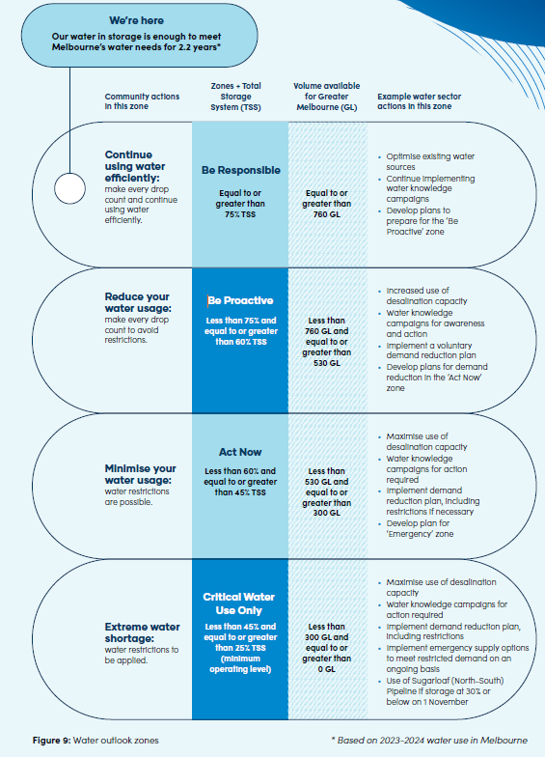
Figure 9: Water outlook zones

Enough water for the future
Melbourne’s population grew by around 140,000 people over the past year — more than the entire city of Ballarat — and is projected to continue. To support current and future growth, in late 2023 the Victorian Government announced Victoria’s Housing Statement, its commitment to build new homes and connect homes to essential services more efficiently.
As both our population and water needs increase, sustained investment in infrastructure is critical to ensure that all new communities and developments have reliable access to the essential services they rely on.
A booming population, variable climate and increasing needs for water, influence long-term water supply and investment. We manage these factors through a range of strategies and plans to make sure we have enough water now and into the future.
We collaborate with a broad group of partners and stakeholders, including different communities, customers, Traditional Owners and many government agencies, to ensure our plans reflect the many voices of the region. The following strategies and plans keep us accountable through delivery and reporting of actions.

Central and Gippsland Region Sustainable Water Strategy (CGRSWS) – Victorian Government
The CGRSWS considers the needs of urban communities, irrigators, Traditional Owners and the environment across the Central (including Melbourne) and Gippsland regions. The CGRSWS provides strategic direction and policy setting at the regional scale to secure the region’s long-term water supplies.
• Read more about the CGRSWS.

Greater Melbourne Urban Water & System Strategy (GMUWSS): Water for Life- Metropolitan water corporations and Melbourne Water
The GMUWSS outlines how the metropolitan water corporations will work together over the next 50 years to keep supplying high-quality water to a growing Melbourne. This strategy identifies multiple scenarios and options to meet our challenges ahead of time.

Find out more about the GMUWSS

Annual water outlooks
We release this Melbourne Annual Water Outlook every December to provide Melbourne with information on what the water industry is doing over the next 12 months and any actions we may need to take to secure water supplies.

Drought preparedness plans
Each water corporation has a drought preparedness plan. Drought preparedness plans include actions that we’ll take to ensure that communities are prepared for the eventuality of drought.

What water corporations are doing:
Improving Melbourne’s water supply to meet future demand
To keep providing Melburnians with a reliable and secure water supply into the future, bulk water supplier Melbourne Water continues to upgrade its reservoirs and expand its drinking water distribution networks.
A major project to upgrade the water treatment plant at Yan Yean Reservoir is now complete. This upgrade allows the reservoir to supply up to 40 million litres of fresh drinking water per day to cater for future demand as Melbourne’s population grows.
A new 20-kilometre pipeline and pumping station from the Yan Yean plant to a new service reservoir at Bald Hill, Kalkallo has been completed and is now operational. The new pipeline has been designed to meet the growing water demands and improve supply reliability in the northern suburbs of Melbourne. It will also free up capacity to transfer more water to the western suburbs.

How we’re tracking against our actions
See the below summary of our activities towards delivering the Minister’s expectations and priority actions in the GMUWSS.
Priority Action | Timing | Status | Update
Overcoming our challenges  Actions 2.1 and 2.4 | Ongoing | On track | We continually improve our understanding of water use in our systems and look for fit-for-purpose alternative supplies.
Ensuring a secure and sustainable water future  Actions 4.1, 4.2, 4.3, 4.4, 4.5, 4.6, 4.7 | Ongoing | On track | We continue to progress readiness activities to make sure we can supply Melbourne’s water needs now and into the future.  Options include:  - enhancing and expanding our existing system (including new manufactured water sources, like desalination)  - integrated water management (including using recycled water and stormwater for non-drinking uses, to reduce demand on our drinking water supplies)  - water efficiency (including finding ways to use less water in our homes, businesses, communities, and distribution networks).
Water for Traditional Owners and the environment  Action 5.5 | Ongoing | On track | We’re working with the Victorian Government to support and enable the return of water to Traditional Owners and the environment.  We’ve started work on the important commitments outlined in CGRSWS to identify opportunities to return water to Traditional Owners, remove barriers to water ownership and strengthen the role of Traditional Owners in water planning and management.  Through genuine partnerships with Traditional Owners, we're committed to working together to maintain and improve the health of Country and support self-determination.
Healthy environment and waterways  Actions 6.1, 6.2, 6.5, 6.6 | Ongoing | On track | We continue to progress stormwater priorities in the Healthy Waterway strategy, IWM action plans and delivery of CGRSWS.  We’re assessing the ongoing role that stormwater plays in fit-for-purpose use in our region. This includes consideration of large-scale stormwater harvesting schemes.  During 2023–24, 45 GL of water for the environment was delivered in the Thomson, Yarra, Tarago, Maribyrnong and Werribee rivers, compared to 24 GL in 2022–23. The releases meet priority watering actions to ensure protection of rivers along with the plants and animals that rely on them.
Partnerships, engagement and education  Action 7.3 | Ongoing | On track | Each year the metropolitan water corporations collaborate on a range of water conservation, literacy programs and community engagement to promote collective action, highlighting to customers that if we each save a little, we all save a lot.

What water corporations are doing:
Helping schools detect leaks and save water and money
The Schools Water Efficiency Program (SWEP), in partnership with water corporations, is helping 955 schools across Melbourne detect leaks and save water and money. The program equips schools with data logger technology, allowing them to track and monitor their water usage in real time. This not only helps schools reduce their water consumption but also educates students about the importance of saving water both at school and at home.
In 2023–24, participating schools saved over 411 million litres of water and $1.6 million. Since the program’s launch in 2012, participating Melbourne schools have saved 6 billion litres of water and $24.5 million has been saved.
What you can do
We all need to continue to look for ways to make every drop count, saving water, as well as reducing bills.
- Follow the Victorian Government's permanent water-saving rules.
- Find more ways to save our precious water.
Follow us on social media for ongoing tips and updates on water savings, water availability and plans to deliver water to meet Melbourne’s growing needs into the future.

